## LAYERS IN THE OSI MODEL (Detailed OSI layers not in syllabus, it’s for your reference)

**Physical Layer**

* Main Responsibility:

Physical-layer (PL) is responsible for movements of individual bits from one node to another node.

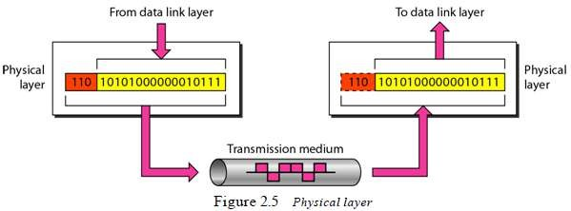

* Other responsibilities of Physical-layer (Figure 2.5):

## Physical Characteristics of Interfaces and Medium

* + PL defines the mechanical/electrical characteristics of the interface & transmission-medium

i.e. Mechanical → cable, plugs, pins

Electrical → modulation, signal strength, voltage levels

* + PL also defines the type of transmission-medium. (Wired or wireless).

## Representation of Bits

* + PL defines the type of encoding i.e. how 0s and 1s are changed to signals.
  + Data consists of a stream of bits: 0s or 1s.
  + Bits must be encoded into signals for transmission.

## Data Rate

* + PL defines the transmission-rate.
  + Transmission-rate refers to the number of bits sent per second.

## Synchronization of Bits

* + PL deals with the synchronization of the transmitter and receiver.
  + The sender and receiver are synchronized at bit-level.

## Line Configuration

* + PL defines the nature of the connection.
  1. In a point-to-point configuration, a dedicated-link is used to connect between 2 devices
  2. In a multipoint configuration, a shared-link is used to connect between 2 or more devices.

## Physical Topology

* + PL defines the type of topology used for connecting the devices in the network.
  + Topologies can be mesh, star, ring or bus.

## Transmission Mode

* + PL defines the direction of data-transfer between 2 devices.
  1. Simplex: Only one device can send; the other device can only receive.
  2. Half-duplex: Two devices can send and receive, but not at the same time.
  3. Full-duplex: Two devices can send and receive at the same time.

VTUNOTESBYSRI

## Data Link Layer

* Main Responsibility:

Data-link-layer (DLL) is responsible for moving frames from one node to another node.

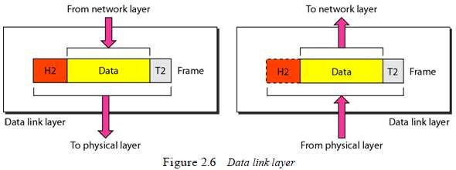

* Other responsibilities of data-link-layer (Figure 2.6 & 2.7):

## Framing

* + DLL receives & divides the stream of bits from network-layer into frames.

## Physical-addressing

* + DLL appends a header to the frame coming from the network-layer.
  + Header contains the physical-address of sender & receiver of the frame.

## Flow Control

* + DLL provides flow-control.
  + Flow-control ensures that source sends the data at a speed at which destination can receive it
  + If there is an overflow at the receiver-side, the data will be lost.

## Error Control

* + DLL provides error-control.
  + Error-control is process of identification or correction of error occurred in the transmitted data
  + Error-control uses mechanisms to

→ detect damaged-frames

→ retransmit lost-frames

→ recognize duplicate frames.

* + Normally, error control information is present in the trailer of a frame.

## Access Control

* + DLL provides access-control.
  + Access-control determines which device has right to send the data in a multipoint connection.

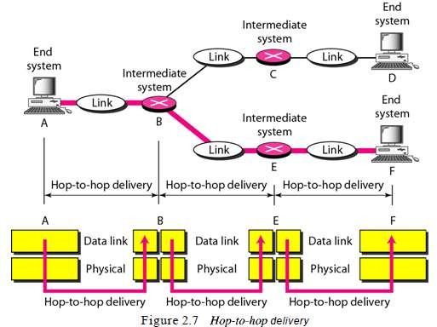

VTUNOTESBYSRI

## Network Layer

* Main Responsibility:

Network-layer (NL) is responsible for source-to-destination delivery of a packet, possibly across multiple-networks.

* Data-link-layer vs. Network-layer:

1. The data-link-layer ensures the delivery of the packet between 2 systems on the same link.
2. The network-layer ensures that each packet gets from the source to the final destination.

* If 2 systems are connected to the same link, there is no need for a network-layer.

However, if the 2 systems are attached to different links, there is often a need for the network- layer to accomplish source-to-destination delivery.

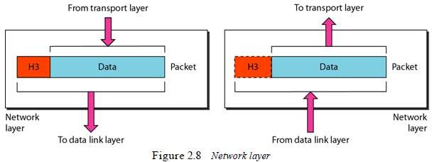

* Other responsibilities of network-layer (Figure 2.8 & 2.9):

## Logical Addressing

* + NL appends a header to the packet coming from the transport-layer.
  + The header contains the IP addresses of the sender and receiver.
  + An IP address is a universally unique address in the network.
  + NL uses IP address to recognize devices on the network.

## Routing

* + NL provides routing of packets.
  + Routing is the process of finding the best path from a source to a destination.
  + Routers/gateways are used for routing the packets to their final destination.
  + NL is concerned with circuit, message or packet switching.

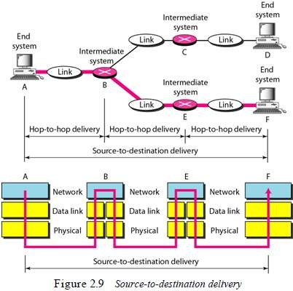

VTUNOTESBYSRI

## Transport Layer

* Main Responsibility:

Transport-layer (TL) is responsible for process-to-process delivery of the entire message.

* Process-to-process delivery means delivery from a specific process on one computer to a specific process on the other computer.
* A process is an application program running on a host.
* Network-layer vs. Transport-layer:

1. Network-layer ensures source-to-destination delivery of individual packets.
2. Transport-layer ensures that the whole message arrives in order

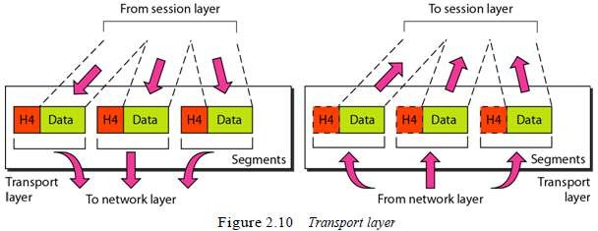

* Other responsibilities of transport-layer (Figure 2.10 & 2.11):

## Service Point Addressing

* + NL appends a header to the segments coming from the network-layer.
  + Header contains the port-address of the sender and receiver.
  + Network-layer vs. Transport-layer:
  1. The network-layer gets each packet to the correct computer.
  2. The transport-layer gets the entire message to the correct process on that computer.

## Segmentation & Reassembly

* + A message is divided into segments.
  + Each segment contains a sequence-number.
  + At receiver, the sequence-numbers are used to

→ rearrange the segments in proper order

→ identify lost/duplicate segments

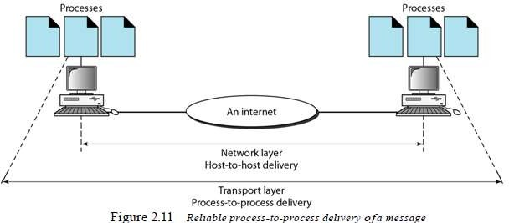

VTUNOTESBYSRI

## Connection Control

* + TL can be either i) connectionless or ii) connection-oriented.
  1. In connectionless, TL

→ treats each segment as an independent packet and

→ delivers the segment to the transport-layer at the destination-machine.

* 1. In connection-oriented, TL

→ first, makes a connection with the destination-machine.

→ then, delivers the packets to the destination-machine.

## Flow Control & Error Control

* + Like DLL, TL is responsible for flow-control & error-control.

However, flow-control & error-control are performed end-to-end rather than node-to-node.

## Session Layer

* Main Responsibility:

Session-layer (SL) establishes, maintains, and synchronizes the interaction between 2 systems.

* Other responsibilities of session-layer (Figure 2.12):

## Dialog Control

* + SL allows 2 systems to start communication with each other in half-duplex or full-duplex.

## Synchronization

* + SL allows a process to add checkpoints into stream of data.
  + The checkpoint is a way of informing the status of the data transfer.
  + For example:

A checkpoint after first 500 bits of data will ensure that those 500 bits are not sent again in case of retransmission at 650th bit. (Checkpoints → Synchronization Points)

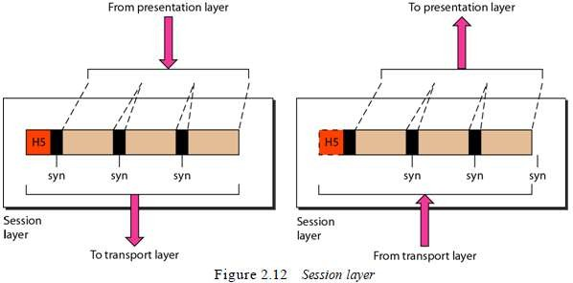

VTUNOTESBYSRI

## Presentation Layer

* Main Responsibility:

Presentation-layer (PL) is concerned with syntax & semantics of the info. exchanged b/w 2 systems.

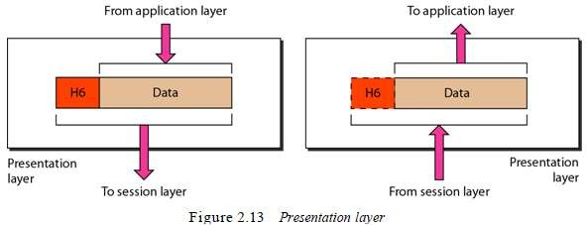

* Other responsibilities of presentation-layer (Figure 2.13):

## Translation

* + PL translates data between

→ format the network requires and

→ format the computer understands.

* + PL is responsible for interoperability between encoding methods as different computers use different encoding-methods.

## Encryption

* + PL performs

→ encryption at the sender and

→ decryption at the receiver.

* + Encryption means the sender transforms the original information to another.
  + Decryption means the receiver transforms the encrypted-message back to its original form.

## Compression

* + PL carries out data compression to reduce the size of the data to be transmitted.
  + Data compression reduces the number of bits contained in the information.
  + Data compression ensures faster data transfer.
  + Data compression is important in transmitting multimedia such as audio, video, etc.

## Application Layer

* Main Responsibility: The application-layer (AL)

→ provides services to the user

→ enables the user to access the network.

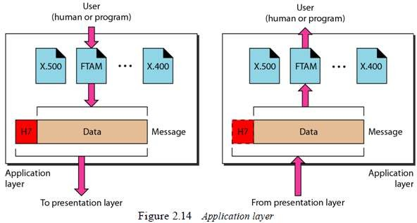

* Other responsibilities of application-layer (Figure 2.14):

1. Mail Services
2. Directory Services
3. File Transfer, Access, and Management